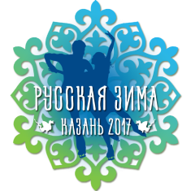
«Russian Winter 2017»
Children and adult amateurs competitions on figure skating
16 – 19th of February 2017 г.

Information letter #2
Dear fans of figure skating – children and its parents, coaches!
1. We offer you to find out more about:
- Regulation with the main information about competitions,
- Requirements to programs and different kinds of program,
- Application forms,
- Form of bank transfer order
On our web-sites: silver-dreаm.org and skаteclub.ru

The Organizing Committee is very glad to see the high interest to our competitions, but has to inform you about some forced measures connected with possible lack of provided time for competitions:
We are very sorry, but:
1) At the present moment the Organizing Committee can’t promise to provide the time for team’s training,
2) The Organizing Committee will limit the receiving of applications in the following way:
ADULTS
- we ask you to pay not more, than 3 programs, but to mark all desired programs;
- to list 3 preferred programs in the text of accompanying letter sent to email.
CHILDREN
- to respect the principle “competitions geography expansion” the Organizing Committee take the right to limit the amount of applications from one club\school to 15 persons at all;
- the applications without name of club and coach will not be accepted till full investigation despite payment is done (in this case entry fee will be returned).
2. The Organizing Committee made an arrangement with one of hotels about significant group discount (20%) to accommodate participants of our competitions, its’ accompany and its’ guests. The information regarding accommodation will be provided in the next Information letters.

Best regards, Organizing Committee of competition “Russian Winter 2017”.

